***Physics Revision Booklet***

Equations and standard values:

|  |  |  |  |  |  |  |
| --- | --- | --- | --- | --- | --- | --- |
|  |  |  |  |  |  |  |
|  |  |  |  |  |  |  |

**Part 1: For the multiple choice questions, make sure you read all the possible answers before choosing and circling your answer.**

1. Who was the scientist who gave us the laws of motion?
   1. Joule
   2. Newton
   3. Watt
   4. Einstein
2. How many laws of motion are there?
   1. 1 c. 2

b. 3 d. 4

1. What is another name for the first law of motion?
   1. The law of Conservation of Mass
   2. The law of Inertia
   3. The law of Conservation of Momentum
   4. The law of Commons
2. In which direction is the weight vector always drawn in a free-body force diagram?
   1. Up
   2. Down
   3. Left
   4. Right
3. If each of the following objects had the same force applied to them, which would be accelerated at the greatest rate?
   1. A tennis ball with a mass of 0·06 kg
   2. A soccer ball with a mass of 0·4 kg
   3. A basketball with a mass of 0·6 kg
   4. A bowling ball with a mass of 2·0 kg

6. Which of the free-body force diagrams below show an object being accelerated?

|  |  |
| --- | --- |
| a. |  |
| b. |  |
| c. |  |
| d. |  |

7. When pushing a box around the room, a boy applies a force of 45 N. The frictional force between the box and the floor is 20 N. What is the net force on the box?

* 1. 20 N
  2. 25 N
  3. 40 N
  4. 65 N

8. The average speed of a snail is estimated to be 0.002 m/s. At this rate, in 1 minute the snail would cover a distance of:

1. 0·012 m.
2. 0·010 m.
3. 1·2 cm.
4. 0·12 m.

9. When objects move through air, a force which opposes them is ‘air resistance’, which is a push by the air back on the objects as they push through the air. Which statement is not true about ‘air resistance’?

* 1. It is useful for parachutists.
  2. It acts in the same direction as motion
  3. It is zero if there is no motion

d. It is also called ‘drag’

**Part 2: Short answer**

1. Two objects have a net force of 100 N acting on them. Object A has a mass of 50 kg; object B has a mass of 20 kg. Which object will have the greatest acceleration? *Explain why*

1. A force (F1) pushes an object to the right and a second force (F2) pushes the object to the left, at the same time. As shown in the diagram below:

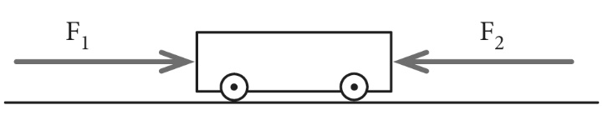

Describe the motion of the object if:

* 1. F1 has the same magnitude as F2

* 1. F1 has a greater magnitude than F2

* 1. F1 has a lesser magnitude than F2

3.. Draw vectors (arrows) to show the forces acting on the brick in each case below. The length of the vector should indicate the relative magnitude of the force. (same magnitude = same length)

1. The brick is falling through the air accelerating towards the ground:

[1 mark]

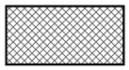

1. The brick is sitting on the ground : [1 mark]

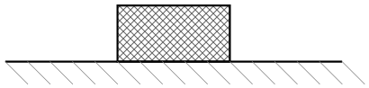

1. The brick is on the ground. The ground is rough. Someone is pushing it to the right. It’s sliding and getting faster (accelerating) :

[2 marks]



1. Newton’s first law of motion states that an objects motion will remain constant unless acted upon by an unbalanced force.  
   What are the three different ways an unbalanced force can change an object’s motion?

1. Four creatures from outer space land on various planets as shown below:

|  |  |  |
| --- | --- | --- |
| **Creature** | **Mass (kg)** | **Weight (N)** |
| M | 40 | 104 |
| N | 20 | 196 |
| O | 10 | 26 |
| P | 20 | 236 |

* 1. Which creature landed on Earth?...............................................................................
  2. Which two landed on the same planet? …………………………………
  3. If all of them came to Earth, which one would weigh the most?...........................
  4. Which creature landed on the planet with the greatest mass?................................…

**Part 3: Calculations**

***Show all working***

1. In the 2007 Australian Motor Cycle Grand Prix at Phillip Island, Victoria, Australia’s Casey Stoner did a lap time of 1 minute 31 seconds for the 4·4 km circuit.
2. **How long in seconds** did he take to complete the lap?
3. **How long in metres** is the circuit?
4. Calculate his **average speed in m/s**:
5. View the free-body diagram below. **What is the magnitude of the unknown force labelled *U***if theobject is accelerating at 6·0 m/s2 to the left?

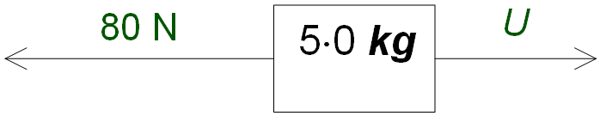

3. Peter is about to lift a box with a mass of 3·4 kg from the floor to a shelf 1·8 m above the ground.

* 1. What is the **weight** of the box?
  2. **How much force** must Peter use to lift the box?

1. A trolley is pushed by a spring with a force of 10 N. The acceleration of the trolley is measured as 20 m/s2. **What is the mass of the trolley?**
2. It took you 12 minutes to run 4.0 km to the bus, what was your average speed.
3. You run one kilometre west then 0.50 km east in 4.5 minutes. What is your average velocity for the run?

7. A student takes 45.0 minutes to walk to school which is 2.60 km, due west from her house.

a) What is her average velocity?

b) In reality the distance she travels is really 3.20 km, because of the route she takes, what is her average speed?

8. In an experiment on scalar and vector quantities, Tyler throws a ball 3.20 m east to Matthew who then throws it 4.50 m west to Daniel. The boys then measured the distance and displacement of the ball.

a) What distance did the ball travel?

b)What was the ball’s displacement?

9. The car travelled forward in the first hour, stopped for an hour and then travelled back home in the last hour.

Now work out the velocity for each section (leave in kmh-1, hours and km)

section one:

section two:

section three: